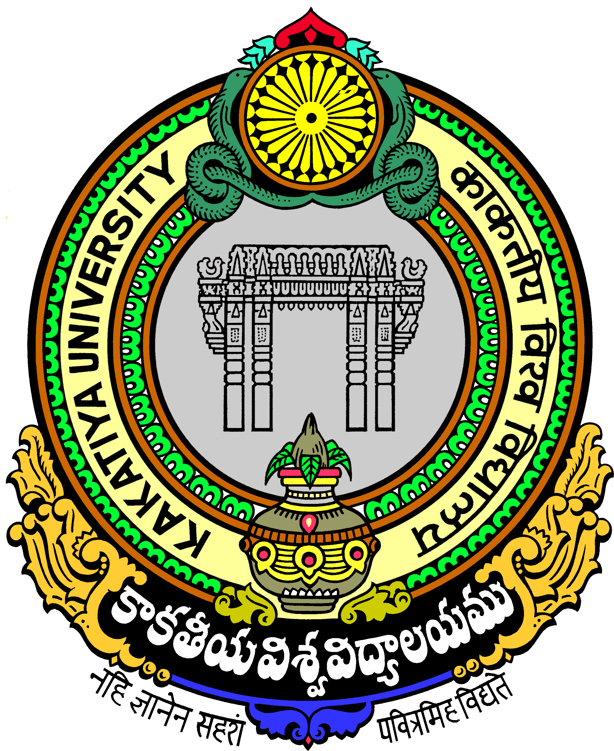
Dr.G.Pani UNIVERSITY SPORTS BOAR SECRETARY kakatiya UNIVERISTY, WARANGAL- 9
CELL NO: 9849316536 OFF: 0870-2438945
Date: 24.12.2016.

FOR FAVOUR OF PRESS Release
The following students will represent Kakatiya University Table Tennis (men) Team in the South-Zone Inter-University Tournament for the year 2015-16 being organized by Anna University, Tamilnadu from Date: 25-12-2016 to 28-12-2016.
.

Sl. No | Name of the student | Name of the studying college
1 | K.Santhosh Varun | Vaagdevi Dc, Hnk, Wgl.
2 | K.Anil | KITS College,WGL
3 | M.Nikhil | KITS College,WGL
4 | S.Vishwa Teja Sharma | KITS College,WGL
5 | V.Rohith Sai | KITS College,WGL
6 | M.Sravan Kumar | CITS, Hnk., Wgl.

Sri. Chaitanya Bhagath, Physical Director, Vaagdevi College of Physical Education, Bollikunta, Warangal as a Coach cum Manager will accompany the Table Tennis (M) Team.

